MANUALLY UPDATING COUNTER

MANUAL UPDATE COUNTER
- We'll add a button to manually update the "Tasks Completed" counter in case there is user error
- We'll place this button on the same row as the "Tasks Completed" counter]

FRAME
- In oder to put widgets on the same row, we need to use a frame
- We'll create a frame that doesn't fill or expand so the frame widget is placed in the top-center of available space
- We'll give it 10 pixels of vertical padding

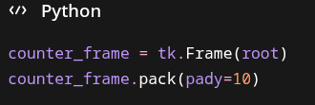

UPDATING TASKS COMPLETED LABEL
- We'll need to reassign the parent window of our Tasks Completed label widget so that it's placed inside our new frame
- We'll also pack it to the left so the label and update button are side-by-side
- We'll give it 5 pixels of horizontal padding between it and the update button

UPDATE COUNTER MANUALLY FUNCTION
- We'll create a new function to manually update tasks completed counter
- When we click this button, a simpledialog widget will appear with an entry field for the user to type in the correct total of the running counter
- We'll first have to import the simpledialog module
- We'll call on our global variable completed_tasks beacuse we want to update it
- We'll use simpledialog.askinteger( ) to ask the user to specify the number they want to see for the running total
- We'll make sure to not update the total if the user clicks Cancel or enters nothing by returning
- We'll update the running total
- We'll save our running total
- We'll update our counter

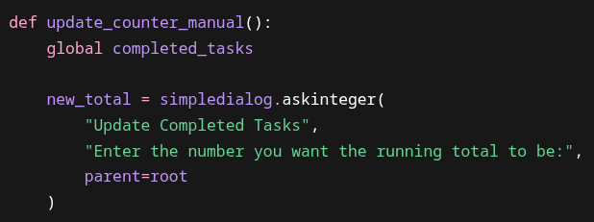

UPDATE COUNTER BUTTON
- We'll create a button as normal
- Place it inside the new frame widget
- Pack it left and give it 5 pixels of horizontal padding

FULL CODE
import tkinter as tk
import json
from tkinter import simpledialog
root = tk.Tk()
root.title("Task List")
root.geometry("500x450")
tasks = []
completed_tasks = 0
def add_task(event=None):
description = task_entry.get()
if description == "":
return
task = {
"description": description,
"completed": False
}
tasks.append(task)
task_listbox.insert(tk.END, description)
save_tasks()
task_entry.delete(0, tk.END)
def delete_task():
selected = task_listbox.curselection()
if selected == ():
return
index = selected[0]
task_listbox.delete(index)
tasks.pop(index)
save_tasks()
def load_tasks():
global tasks
global completed_tasks
try:
with open("testtasks.json", "r") as file:
data = json.load(file)
tasks = data["tasks"]
completed_tasks = data["completed_tasks"]
for task in tasks:
task_listbox.insert(tk.END, task["description"])
except FileNotFoundError:
tasks = []
completed_tasks = 0
def mark_completed():
global completed_tasks
selected = task_listbox.curselection()
if selected == ():
return
index = selected[0]
task_listbox.delete(index)
tasks.pop(index)
completed_tasks += 1
save_tasks()
update_counter()
def save_tasks():
data = {
"completed_tasks": completed_tasks,
"tasks": tasks
}
with open("tasks.json", "w") as file:
json.dump(data, file)
def update_counter():
counter_label.config(text=f"Tasks Completed: {completed_tasks}")
def update_counter_manual():
global completed_tasks
new_total = simpledialog.askinteger(
"Update Completed Tasks",
"Enter the number you want the running total to be:",
parent=root
)
if new_total == None:
return
completed_tasks = new_total
save_tasks()
update_counter()
task_listbox = tk.Listbox(root, font=("Arial", 14), width=40, height=10)
task_listbox.pack(pady=10)
load_tasks()
task_entry = tk.Entry(root, font=("Arial", 14))
task_entry.bind("<Return>", add_task)
task_entry.pack(pady=10)
button_frame = tk.Frame(root)
button_frame.pack(pady=5, fill="x", padx=40)
delete_button = tk.Button(button_frame, text="Delete Task", font=("Arial", 12), command=delete_task)
delete_button.pack(side="left", padx=5)
add_button = tk.Button(button_frame, text="Add Task", font=("Arial", 12), command=add_task)
add_button.pack(side="left", padx=5)
mark_button = tk.Button(button_frame, text="Mark Completed", font=("Arial", 12), command=mark_completed)
mark_button.pack(side="left", padx=10)
counter_frame = tk.Frame(root)
counter_frame.pack(pady=10)
counter_label = tk.Label(counter_frame, text=f"Tasks Completed: {completed_tasks}", font=("Arial", 14))
counter_label.pack(side="left", padx=5)
update_counter_button = tk.Button(counter_frame, text="Update", font=("Arial", 12), command=update_counter_manual)
update_counter_button.pack(side="left", padx=5)
root.mainloop()

